**PORTFOLIO**

**Week 1:**

Using Visual Studio Code, I created my first JavaScript program, which I saved as “week1.js” in a folder named “CN5006”. You can view this program in the screenshot on the left.   
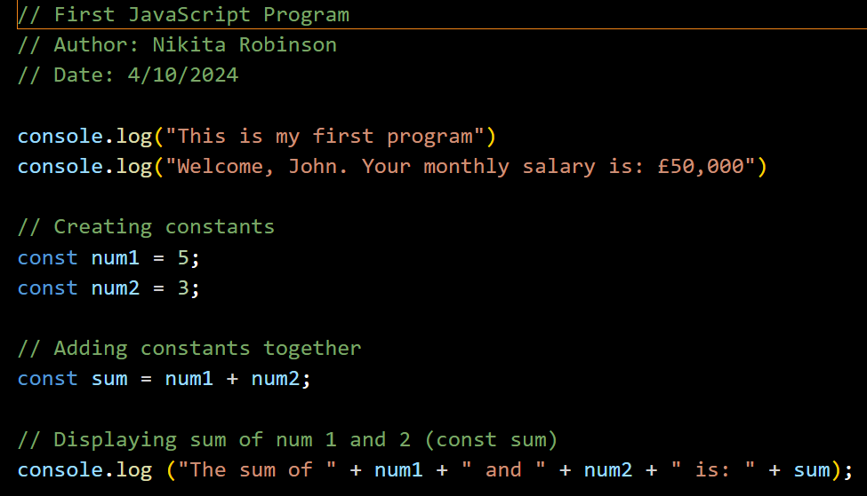

The next step was opening the terminal, where I inputted the “pwd” command to open the directory. Then I needed to input “node” along with the name of my program. Since this program was named “week1”, I input the prompt “node week1”. You can view the results in the screenshot below.

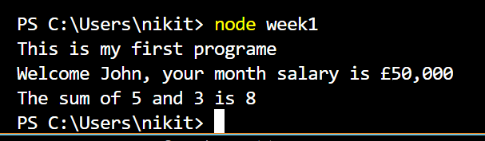

On the left is a screenshot of a more complex program which checks if a number is positive, negative or equal to 0. Upon compiling this program, I found that it could not be executed in the terminal, as ”prompt is not defined”. Upon further investigation, I discovered that the prompt() function is not natively available. To remedy this, I added the following line:   
“var prompt = require(‘prompt-sync’)();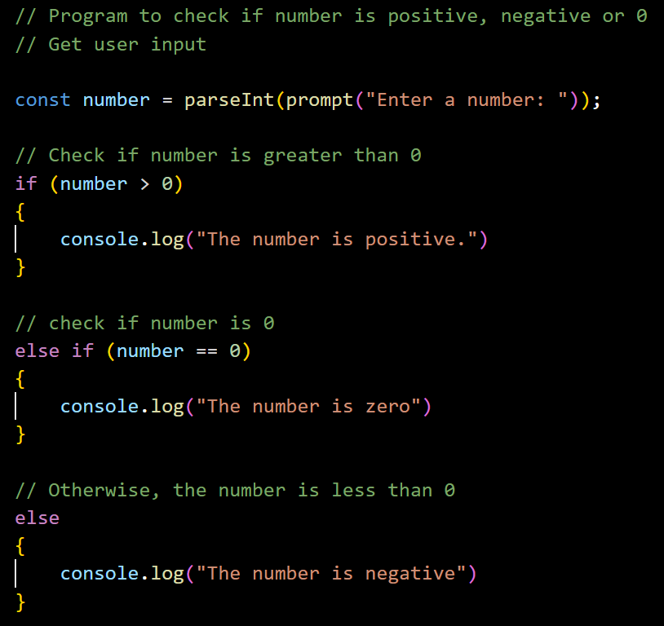

The prompt allowed me to input a number in the terminal. Below is a screenshot of the results.



With my knowledge, I then created an application which could add, subtract, multiply, and divide two numbers. Screenshots of the program and the results are provided below.

